# **Flask To-Do App — GitHub Project Submission**

**GitHub Repository:**<https://github.com/SONU8294/flask-todo-app>

## **Step 1 — Repository Setup & Initial Branch**

1. Created a new GitHub repository: flask-todo-app.
2. Cloned repository via SSH.
3. Created initial branch SONU8294.
4. Added initial Flask project files: app.py, templates/todo.html, data.json.
5. Merged SONU8294 into main.

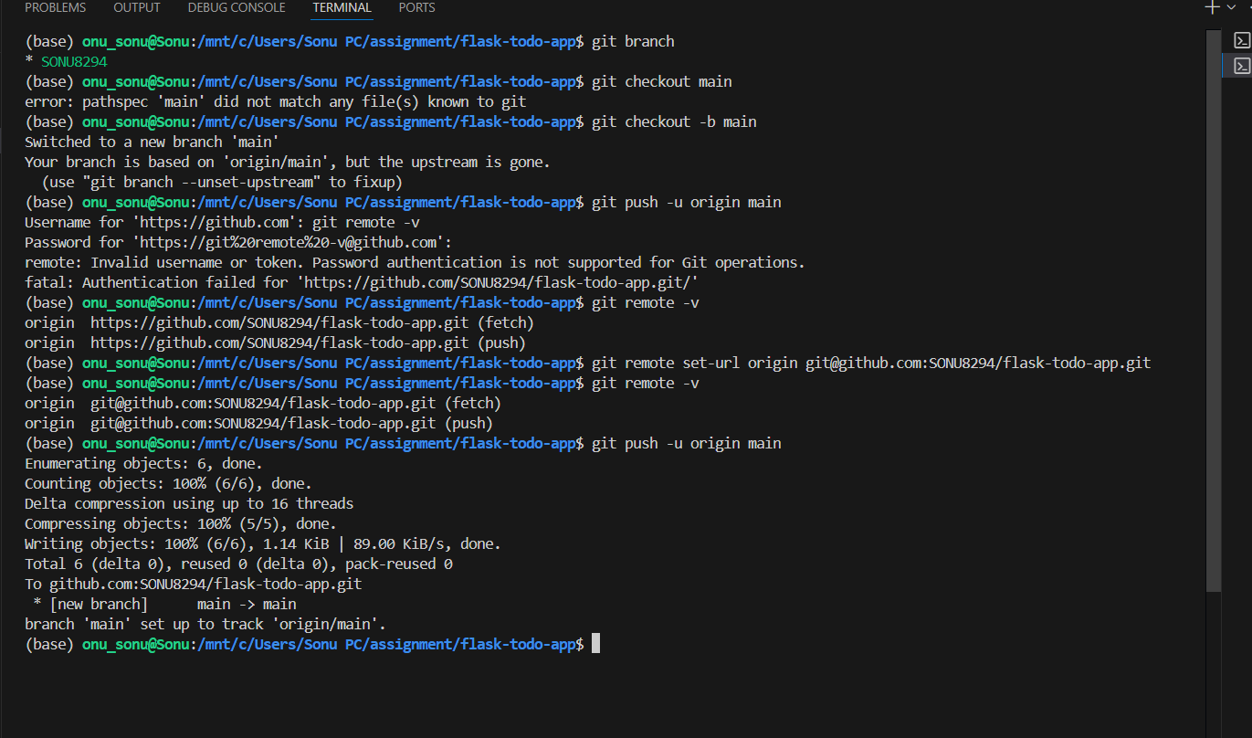

## **Step 2 — Create SONU8294_new & Update JSON**

1. Created branch SONU8294_new.
2. Updated data.json with new tasks.
3. Committed & pushed changes.
4. Merged into main.

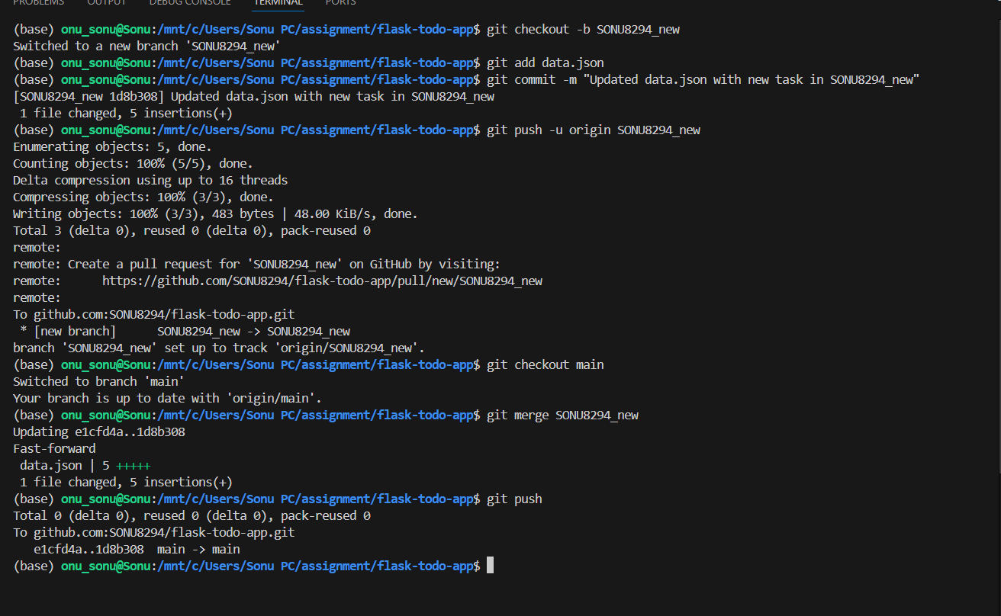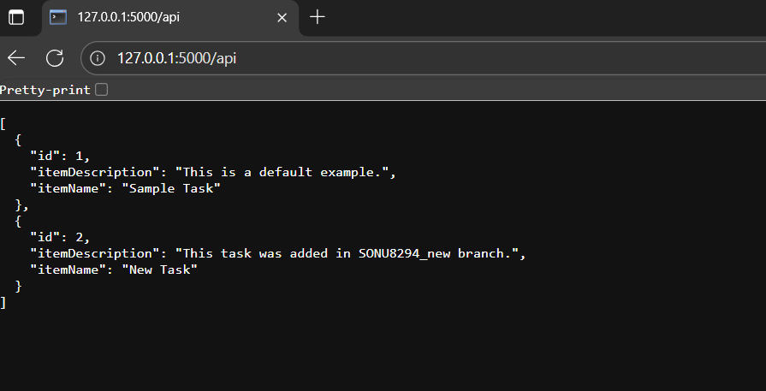

## **Step 3 — Branches for Frontend & Backend**

### **Frontend (master_1)**

* Created branch master_1.
* Updated todo.html with form:

<form action="/submittodoitem" method="post">

<input type="text" name="itemName" placeholder="Item Name" required><br><br>

<input type="text" name="itemDescription" placeholder="Item Description" required><br><br>

<input type="submit" value="Add Item">

</form>

* Committed & pushed changes.

### **Backend (master_2)**

* Created branch master_2.
* Added /submittodoitem route in app.py.
* Committed & pushed changes.

### **Merge Frontend & Backend into main**

* Merged both branches into main.

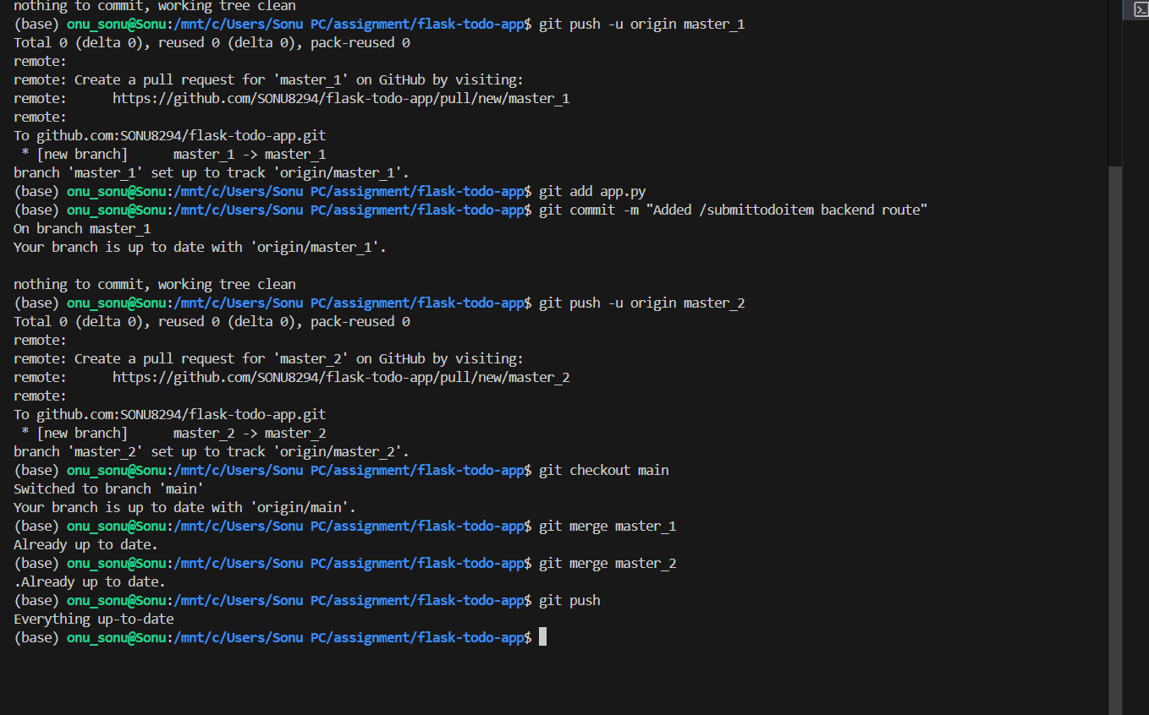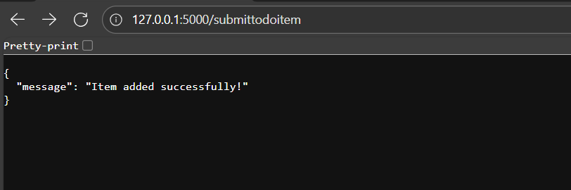

## **Step 4 — Enhance To-Do Form**

1. Added Item ID field (commit 1).
2. Added Item UUID field (commit 2).
3. Added Item Hash field (commit 3).

### **Merge & Git Reset**

* Merged master_1 into main.
* Soft reset main to keep only Item ID.
* Committed and pushed changes.

### **Rebase master_1**

* Rebased main into master_1, resolved conflicts.
* Pushed rebased branch.

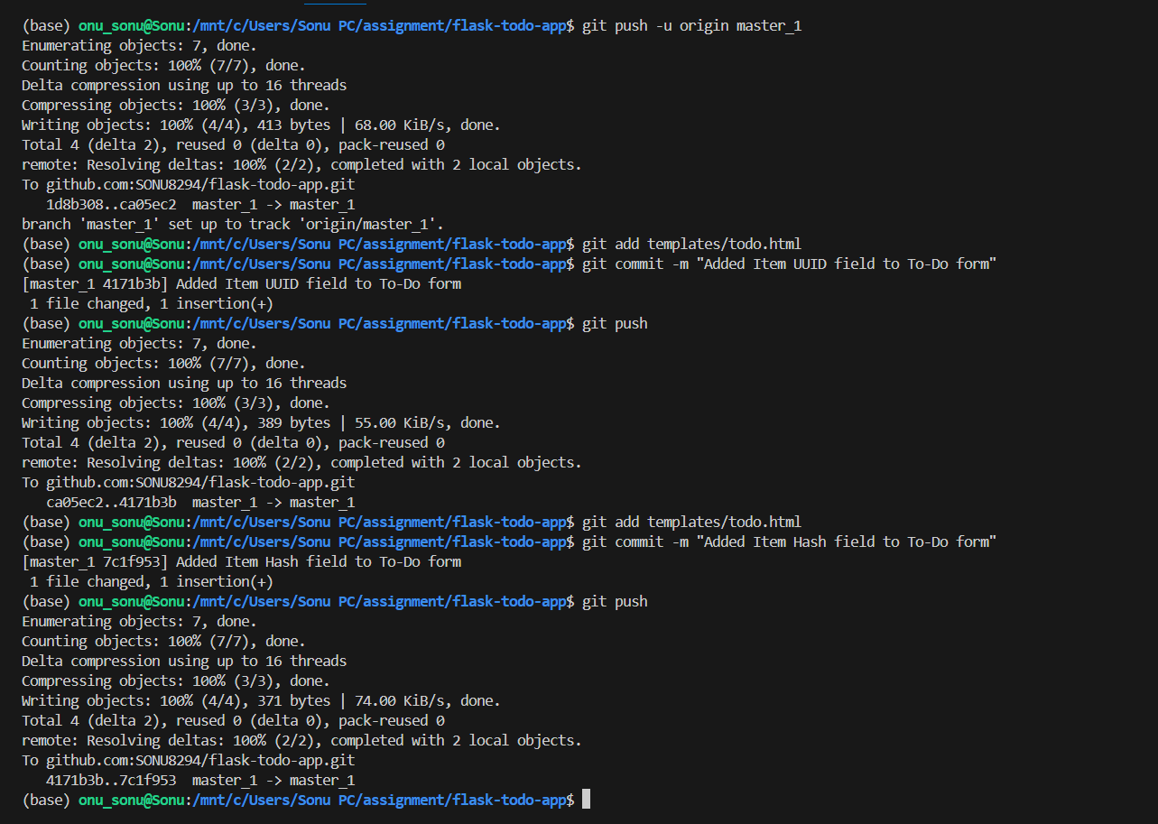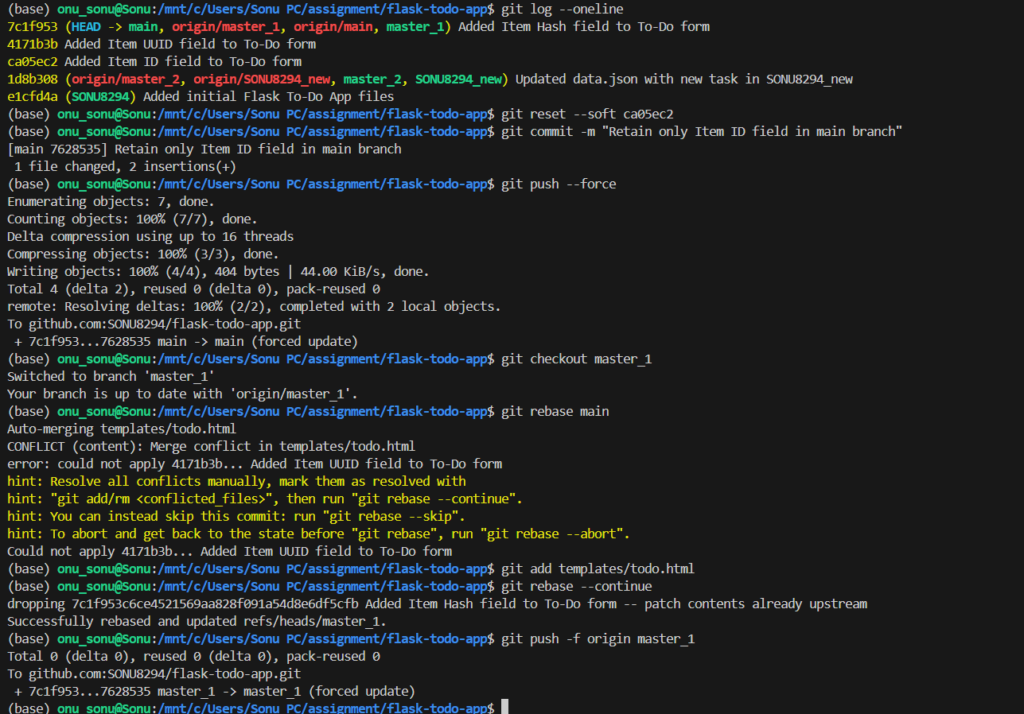

## **Step 5 — MongoDB Integration**

* Connected to MongoDB Atlas free cluster.
* /submittodoitem route inserts items into database.

